InfraRed Multi-slit Spectrometer (IRMS)

Science Objectives

- Detection of metal-free star formation in First Light Objects
- Baryons at epoch of peak galaxy formation
- Rest-frame optical properties of high redshift galaxies

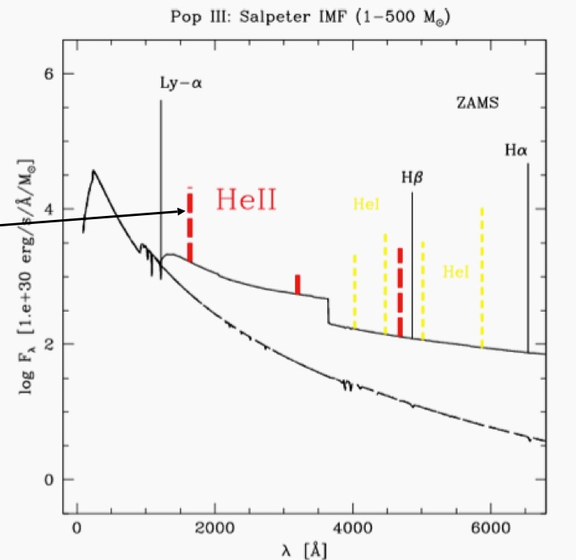
Figure 1: Predicted spectrum of First Light objects. Spectrum of a Pop III ZAMS burst (from Schaerer 2002) based on non-LTE model atmospheres including H and He recombination lines. The dashed line shows the pure stellar continuum (neglecting nebular emission). Note the prominent line of He II 1640 (arrow) and the importance of nebular continuous emission. Simulations indicate that the He II line, which decays rapidly within 2 Myr, is a valuable tracer of metal-free stellar populations.

Top-level Observatory Requirements

Requirement ID | Description | Requirement
[REQ-1-ORD-3840] | Wavelength range | The instrument shall operate over the Y, J, H, K bands
[REQ-1-ORD-3845] | Wavelength coverage | The instrument shall cover an entire band at a time
[REQ-1-ORD-3850] | Image quality | Aberrations uncorrectable by an order 60x60 AO system should not add wavefront errors larger than 30 nm RMS
[REQ-1-ORD-3855] | Field of view | Shall utilize the 2 arcminute NFIRAOS technical field
[REQ-1-ORD-3860] | Spectral Resolution | R > 3000 with a 120 milliarcsecond slit
[REQ-1-ORD-3865] | Throughput | > 35%, not including telescope or NFIRAOS
[REQ-1-ORD-3870] | Imaging mode | Shall provide imaging over the full field of NFIRAOS

Description

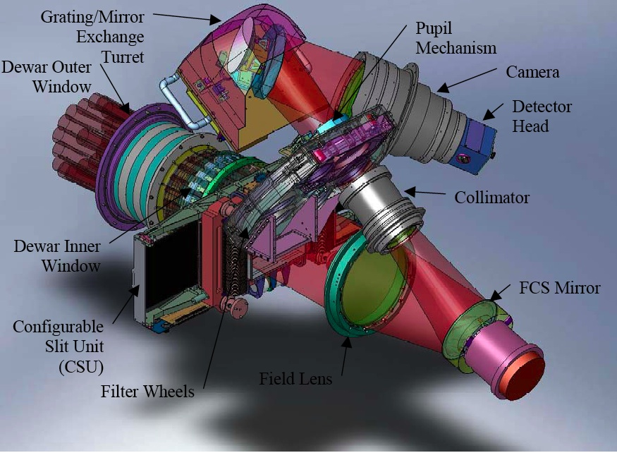 | 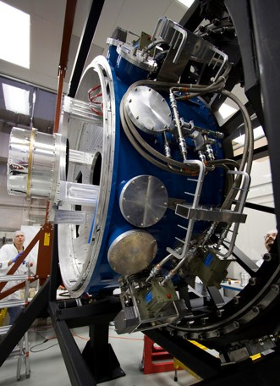
Figure 2: (Left) Layout of MOSFIRE, (Right) MOSFIRE integration at Caltech

Some form of multi-object NIR spectroscopy is another essential capability for early light. Understanding the so-called “First Light” objects in the Universe, the origin and evolution of galaxies and other objects detected by JWST and ALMA will require spectra of many extremely faint objects in the NIR, and multiplexing will thus be essential. Although SAC advocated a fully multiplexed deployable IFU system using MOAO, this was judged to be too risky and expensive for an early light instrument. Fortuitously a close copy of the MOSFIRE multislit instrument (Figure 2), currently being operated at Keck, provides a very exciting interim capability. Although MOSFIRE is a seeing-limited instrument for Keck, it can be easily adapted for use in an AO mode with NFIRAOS (Figure 3), providing an exceedingly powerful capability for TMT at low risk and modest cost.

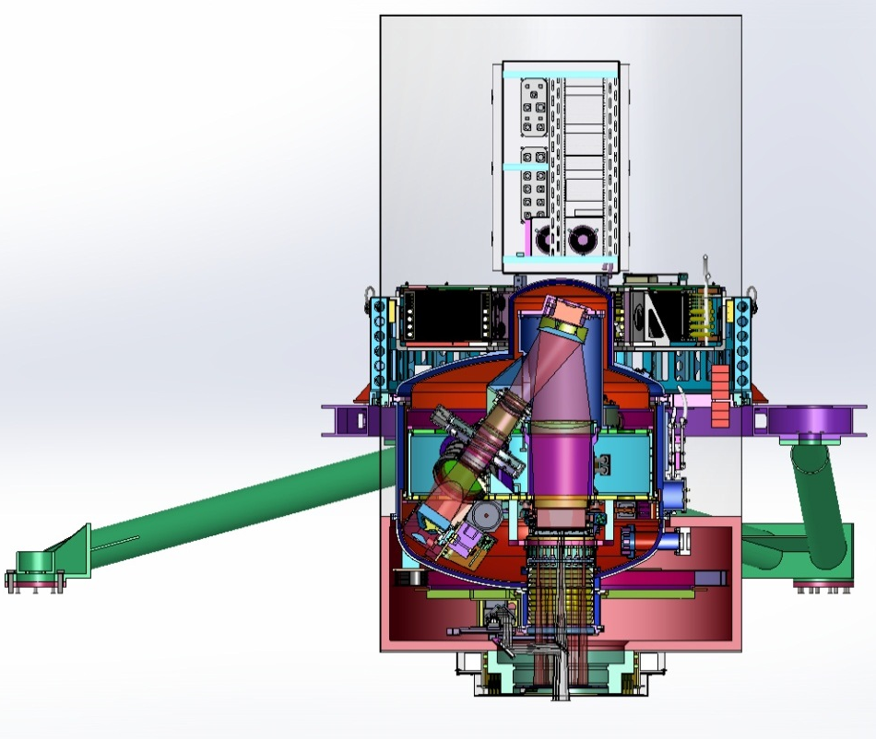
Figure 3: IRMS based on the MOSFIRE design, shown in the orientation as installed on the NFIRAOS first light adaptive optics system. On top is the electronics cabinet and the support structure to NFIRAOS is in green.

When optimized for wide-field mode, NFIRAOS will deliver images to IRMS that will produce almost an order of magnitude gain in encircled energy within narrow (160mas) slits over the entire of 2’ diameter field. NFIRAOS+IRMS is expected to deliver a K-band encircled energy within a radius of 80 milliarcsec six times higher than for seeing limited observations (Figure 4).

MOSFIRE is a multi-slit instrument designed for the f/15 Cassegrain focus on the Keck 1 telescope. This is the same f/ratio as for the TMT Nasmyth focus and, with modest changes to the MOSFIRE design, it would naturally take in the entirety of the NFIRAOS field of regard of 2’ diameter.

MOSFIRE uses a cryogenic slit mask unit (CSU) that was originally developed as a back up for the JWST NIRSPEC instrument. The spatial pixel scale of IRMS on TMT is reasonably well matched to the sampling scale (50mas) requested in the SRD for IRMOS and the length of individual slitlets (made by masking bars in MOSFIRE) is similar to the recommended scale for IRMOS. For multiplexing, the individual bars can be configured in up to 46 slitlets over the entire NFIRAOS field; in practice, some of the slitlets would be made into contiguous slits of lengths that are multiples of 2′′.4. The width of slits and their placement within the field are remotely configurable in real time.

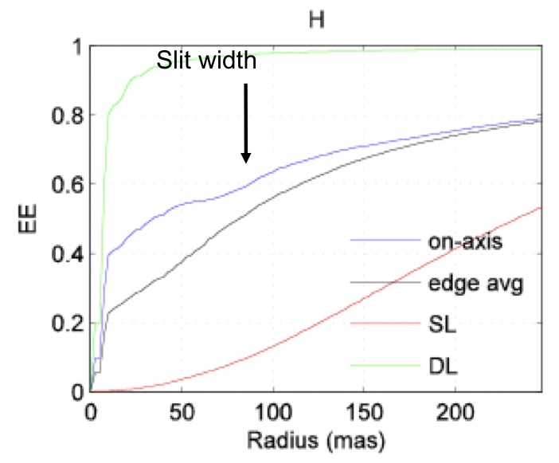
Figure 4: Encircled energy curves for the NFIRAOS/IRMS system. The gain within narrow (160 mas) slits over the seeing limited case is almost an order of magnitude over the entire 2’ diameter field.

IRMS on TMT will also offer additional capabilities. It can be configured as a long slit spectrograph or as an imager that would cover the entire NFIRAOS field of regard, albeit with spatial sampling of only 33-60mas (roughly 2-4 times larger than the diffraction limit at 2 microns). It could also be used in a seeing-limited mode (for either imaging or spectroscopy) if desired, by flattening the deformable mirrors in NFIRAOS and turning off the AO correction.

References

- MOSFIRE website (http://www.astro.ucla.edu/~irlab/mosfire/)
- MOSFIRE Detailed Design Report v2.0 (http://irlab.astro.ucla.edu/mosfire/MOSFIRE DDR Report v2.pdf)
- MOSFIRE Requirements v1.4 (http://irlab.astro.ucla.edu/mosfire/MOSFIRE Requirements_1_4.pdf)
- McLean, I. S. et al., “MOSFIRE: a multi-object near-infrared spectrograph and imager for the Keck Observatory”, 2008, SPIE, 7014, 99
- Spanoudakis, P. et al., “Configurable slit-mask unit of the multi-object spectrometer for infra-red exploration for the Keck telescope: integration and tests.”, 2008, SPIE, 7018, 14

