TMT Instrumentation Overview

The instrument suite that responds to the TMT scientific objectives is comprised of the nine capabilities (Table 1) plus the Near-IR Adaptive Optics System (NFIRAOS): a dual-conjugate (MCAO) system that provides diffraction-limited images over the wavelength range 0.8-2.5µm over a 30 arcsec field, and partially corrected images over a >2 arcmin field. The performance requirements will be met in median conditions with better than 50 percent sky coverage at the galactic poles. NFIRAOS is supported by a Laser Guide Star Facility capable of launching an asterism of six laser guide stars. NFIRAOS will feed diffraction limited images to IRIS and IRMS initially, and eventually to NIRES and WIRC. The instruments are located on two Nasmyth platforms (Figure 1), and an articulated tertiary mirror directs the telescope beam to the instrument stations. This configuration offers a number of key advantages: 1) multiple instruments can be addressed quickly with reduced overheads, 2) science with targets of opportunity and transient objects can be pursued, 3) throughput losses and thermal background are minimized, and 4) large and sensitive instruments operate in a gravity invariant, highly stable, and low vibration environment.

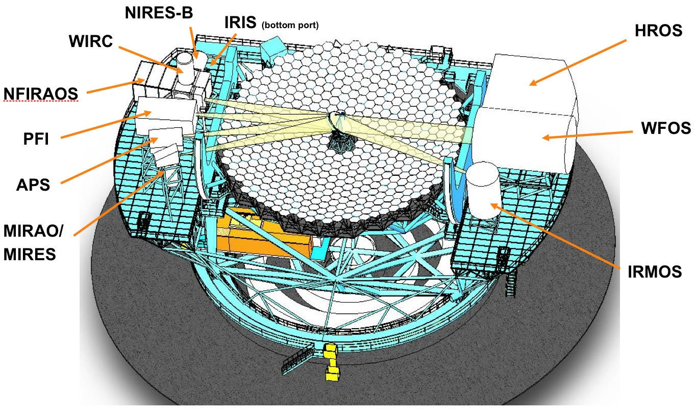
Figure 1: TMT First Decade instruments on the Nasmyth platforms

Feasibility studies of the instrument capabilities listed in Table 1 in 2005-2006 provided the opportunity to explore the potential of TMT equipped with realistic instruments, and to verify and expand on the overall observatory requirements. After reviewing the instrument concepts, capabilities, and costs, the suite of science instruments was divided by the TMT Science Advisory Committee (SAC) in December 2006 into “early light'' and “first decade'' instruments. This selection was based on scientific priority and synergies with JWST and ALMA as well as a variety of pragmatic reasons, including funding constraints, commissioning practicalities, and technological readiness.

The early light suite consists of three “workhorse instruments”: IRIS, a near-IR integral field spectrograph and imager working at the diffraction limit; WFOS, a seeing-limited wide-field multi-object spectrograph; and IRMS, a multislit near-IR spectrograph and imager. IRIS and IRMS will be fed by the facility AO system, NFIRAOS. The latter and the three early light instruments will be funded by construction funds and are included in the overall TMT Observatory Cost Estimate. Conceptual designs of these instruments will be completed in 2010-11.

Table 1: Instrument capabilities planned for the first decade of TMT operations. The first three are early light instruments.
Instrument | Field of view / slit length | Spectral resolution | λ (µm) | Comments
InfraRed Imager and Spectrometer  (IRIS) | < 3′′ IFU >15”imaging | > 3500  5-100 (imaging) | 0.8 – 2.5  0.6 –5(goal) | NFIRAOS
Wide-field Optical spectrometer and imager  (WFOS) | >40 arcmin²  >100 arcmin² (goal)  Slit length>500” | 1000-5000  >7500 @0.75” (goal) | 0.31-1.0  0.3-1.5(goal) | Seeing-Limited  (SL)
InfraRed Multislit Spectrometer (IRMS) | 2 arcmin field 46 deployable slits | R=4660 @ 0.16 arcsec slit | 0.95-2.45 | NFIRAOS
Multi-IFU imaging spectrometer (IRMOS) | 3′′ IFUs over >5’ diameter field | 2000-10000 | 0.8-2.5 | MOAO
Mid-IR AO-fed Echelle Spectrometer (MIRES) | 3′′ slit length  10′′ imaging | 5000-100000 | 8-18  4.5-28(goal) | MIRAO
Planet Formation Instrument  (PFI) | 1′′ outer working angle, 0.05′′ inner working angle | R≤100 | 1-2.5  1-5 (goal) | 10⁸ contrast  10⁹ goal
Near-IR AO-fed Echelle Spectrometer (NIRES) | 2′′ slit length | 20000-100000 | 1-5 | NFIRAOS
High-Resolution Optical Spectrometer (HROS) | 5′′ slit length | 50000 | 0.31-1.1  0.31-1.3(goal) | SL
“Wide”-field AO imager  (WIRC) | 30′′ imaging field | 5-100 | 0.8-5.0  0.6-5.0(goal) | NFIRAOS

The key variables defining the TMT discovery space are flux, spectral and spatial resolution, and wavelength coverage. Figure 2 graphically shows one projection of that discovery space that extremely large telescopes will be able to explore particularly well. The overlap between science programs and planned instrument capabilities is excellent.

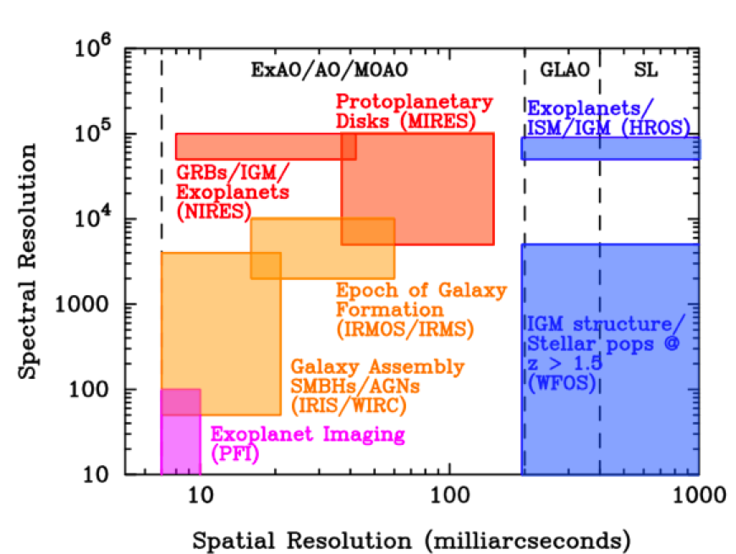
Figure 2: Science programs and instrumentation capabilities in spectral versus spatial resolution discovery space.

